**Project Report**

**on**

**Tic Tac Toe on LAN**

**Submitted by:**

|  |  |
| --- | --- |
| **Name** | **Registration Number** |
| Ambadkar Tanmay | **201851018** |
| Anvay Mishra | **201851026** |
| Prateek Chouhan | **201851089** |
| Harsh Kakani | **201852011** |

**Submitted to**

**Dr. Antriksh Goswami**



**Indian Institute of Information Technology Vadodara**

**Gandhinagar, Gujarat, India – 382028**

**November 2020**

# **Project analysis**

The project was creating a tic tac toe game for LAN play . It involves a TCP Server to which two clients can connect and play the game of tic tac toe . For this project , the server starts listening to incoming connections and waits for two incoming client requests to start the game . Once the connection is established , the players take turns to play . The position of the move is transferred to the server by the client. The server then serves this position to the other player as well . There is a timeout of certain duration within which the player must make his move during his turn . If he fails to do so then the connection is closed from the client’s side and the other player wins. If none of the players times out then the game closes after a certain duration.

# **Design(Flow chart for your implemented project)**

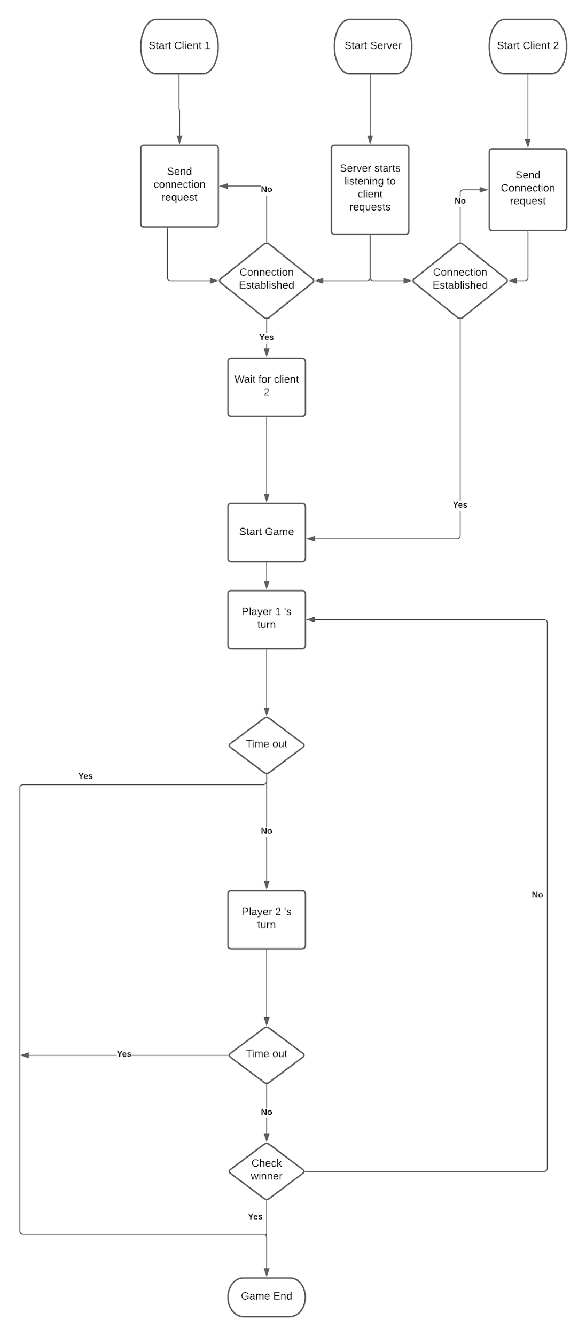

# **Requirements of you project**

The requirements to run this project are listed below :-

1. **Python 3.6**
2. PyGame
3. Sockets
4. Func_timeout

# **Any project relevant information**

**Network Socket** :- A network socket is a software structure within a [network node](https://en.wikipedia.org/wiki/Node_(networking)) of a computer network that serves as an endpoint for sending and receiving data across the network. The structure and properties of a socket are defined by an [application programming interface](https://en.wikipedia.org/wiki/Application_programming_interface) (API) for the networking architecture. Sockets are created only during the lifetime of a [process](https://en.wikipedia.org/wiki/Process_(computing)) of an application running in the node.

**TCP :-** TCP (Transmission Control Protocol) is a standard that defines how to establish and maintain [a network conversation](https://www.searchmobilecomputing.techtarget.com/opinion/Deep-dive-into-internet-capacity-during-a-pandemic) through which application programs can exchange data. TCP works with the Internet Protocol ([IP](https://searchunifiedcommunications.techtarget.com/definition/Internet-Protocol)), which defines how computers send [packets](https://searchnetworking.techtarget.com/definition/packet) of data to each other. In a TCP Protocol , the server listens to the client’s request , once the client sends a connection request , the server acknowledges it and a connection is established by such a handshake. The Client then sends data packets to the server for communication and the server sends an acknowledgement .

**Usage in the project :-**  In this project we utilised TCP to establish connections between the server and the two clients . We made use of socket programming in **Python 3** .

**Steps to execute complete project :**

1. **Installation and extraction :** 
   1. Extract the project in your desired location.
2. **Setting up the environment :**
   1. Installing libraries: Enter the following commands in the terminal
      1. *pip install pygame*
      2. *pip install func_timeout*
3. **Running the code :** 
   1. Open three terminals and go to the extracted folder.
   2. In any of the terminals run the following command : *python server.py.*
   3. Then in the remaining two terminals run the following command: *python game.py*
4. **Playing the game :**
   1. Ensure that you make your move only during your turn.
   2. If you make your move when its not your turn, your move will be discarded
   3. The standard rules of tic tac toe apply.
   4. You have 30 seconds to make your move, after which you will be timed out and the other player will win

# 

# **Outputs for code**

